Position Description | Te whakaturanga ō mahi

Title | Oranga Coordinator
Reporting manager | Oranga Coordinator Team Lead
Department | Māori Provider Services
Location | Auckland City Hospital
Full time equivalent (FTE) | 1
Date reviewed | July 2025

Kia kotahi te oranga mo te iti me te rahi o te hāpori

Healthy communities | World-class healthcare | Achieved together

Te Toka Tumai recognises and respects Te Tiriti o Waitangi as the founding document which encapsulates the fundamental relationship between the Crown and Iwi. This established the New Zealand Government and defined Aotearoa as a bi-cultural nation. As a bi-cultural organisation, Te Toka Tumai understands that as Tangata Tiriti we have a Tiriti o Waitangi responsibility for Māori health improvement and a legislative responsibility to eliminate health inequities.
Our vision is to support our local population to achieve the outcomes determined for themselves, their whānau and their community, and to ensure high quality, safe and equitable services are accessible when needed. Our approach is patient and whānau-centred healthcare, which means people are at the heart of everything we do.
Our purpose is to support our population to be well and healthy, with special emphasis on accelerating health gain for Māori and achieving equitable health outcomes across our community. We commission health and disability services across the whole system from problem prevention to end of life care. We provide specialist healthcare services to patients and whānau from across districts, Aotearoa, and the Pacific.

About our values

Our shared values are the foundation to how we do things at Te Toka Tumai. It is about how we treat people, and about how we make our patients, whānau and each other feel.
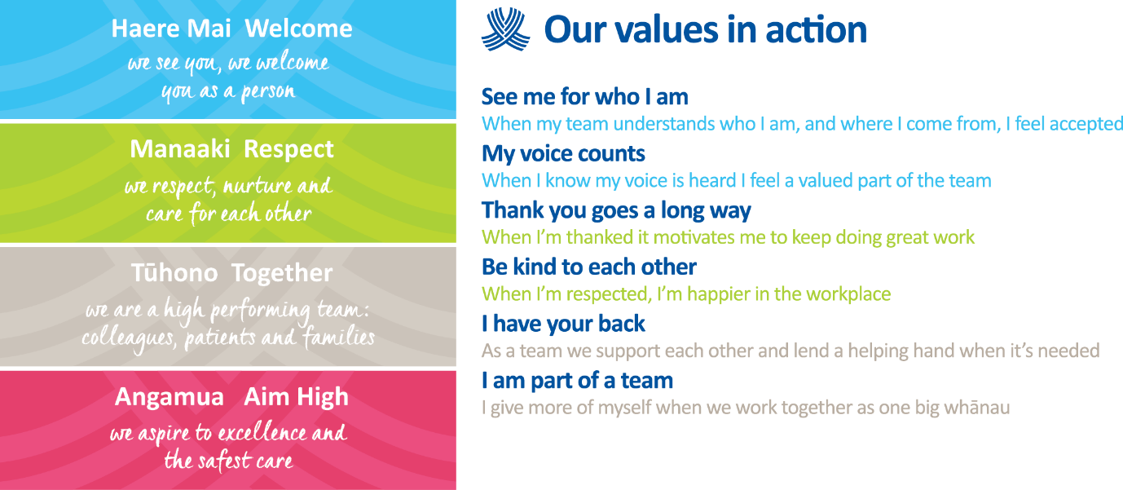

Context for the role

The Oranga Coordinator reports to the Oranga Coordinator Team Lead and supports Te Toka Tumai’s Māori patients and whānau by:
- Ensuring patients and whānau are empowered, have confidence in the service Te Toka Tumai provide them and trust the benefits to themselves, and their whānau.
- Foster an environment that ensures patients and whānau have a good experience, and work in partnership to identify any barriers to optimal health outcomes for the patient.
- Safeguard appropriate levels of engagement between the patient, whānau and Te Toka Tumai workforce.

About the role

The primary purpose of the role is to:
- Play a key role in ensuring Māori patients and whānau at Auckland City Hospital have the best possible inpatient, outpatient, community and whānau experience.
- You will work in active partnership with colleagues to identify any barriers to provision of excellent assessment and treatment, ensuring delivery of care incorporates a cultural lens during inpatient, outpatient and community admission and through the discharge process.
- You will work closely with patients and whānau to provide support and guidance when presenting to the hospital and through the duration of their inpatient, outpatient or community admission.
- Care must be taken at all times to avoid taking on responsibilities of the whānau; this role is to provide support and guidance to whānau, to help them develop their own coping mechanisms and strengthen their ability to support the patient in the post-discharge period.

Key result area | Expected outcomes / performance indicators – position specific
Better, Best and Brilliant Whānau Experiences (customer service) | - The critical outcome is that patients and their whānau feel empowered and respected in their journey to wellness through the acknowledgement, protection and enhancement of their mana.  - Work with other Oranga Coordinators to coordinate engagement with patients and whānau to korero, manaaki and tautoko all Māori patients. Patients and whānau may have widely variable experiences, depending on their clinical diagnosis, their cultural, social and household situations and their underlying health conditions which you will need to be able to provide a comforting support through whakawhanaungatanga and manaakitanga.  - Liaise between the patients, whānau and health care teams to ensure that they have the best possible care and whānau experience.  - Arrange meetings between whānau and the health care teams  - Care should be taken to understand the home and whānau situation as this will have an impact on when and if patients can be discharged home requiring potential liaison with necessary team to facilitate safe discharge.  - Attend all necessary meetings including Oranga Coordinator handovers to review all patient statuses, ward handovers, update notes and plan the next day’s work. Complete and keep update all necessary notes and documentation.
To work collaboratively with key stakeholders and whānau | - Working collaboratively with multi-disciplinary team members to provide a consistent and coherent approach to service delivery.  - Adopting a Te Whare Tapa Wha approach to care for patients and whānau, recognising the wellbeing and welfare of the whānau contribute significantly to the journey and positive long term outcomes for whānau.  - Ensuring effective communication with patients and their whānau and other staff in the hospital.  - Working collaboratively with other agencies, as required, to ensure successful access of services.
Inter-professional health care and quality improvements | - The professional and political integrity of Auckland DHB is upheld by carrying out all functions in compliance of Te Tiriti o Waitangi and by demonstrating a serious commitment to keeping the treaty alive.  - Actively promotes Māori attitudes and values in line with Tikanga Best practice, Te Tiriti o Waitangi, Pae Ora and Patient Code of Rights in service delivery with patients and whānau.  - Ensuring Te Toka Tumai values (Haere Mai, Manaaki, Tuhono, Angamua) and Kaiārahi Nāhi values (Whanaungatanga, Manaakitanga, Kotahitanga and Rangatiratanga) are embedded in every patient and whānau interaction.  - Sensitivity to cultural complexity in the workforce is demonstrated.  - Collaborating and participating with colleagues and members of the health care team to facilitate and coordinate care.  - Recognising and valuing the roles and skills of all members of the health care team in the delivery of care.  - Appropriate services both within and outside Te Toka Tumai are liaised with to support the positive experience of whānau (such as the other care services, translation, chaplain and other cultural services).  - Providing support and guidance to new staff through orientation and peer support.  - Participates in service quality evaluation activities and education sessions.  - Engages actively in research activities that relate to Maori experience of healthcare
Rosters | - This is a rostered position working Monday – Sunday, 40 hours per week, shifts will be agreed between the Oranga Coordinator and the hiring manager.
Patient Notes and Recordkeeping | - Use necessary service platforms and spreadsheets to maintain up to date patient notes, daily updates, handover and any relevant documentation.  - Effective data collection and reporting (Quantitative and Qualitative) is in place to support service outcome reporting and planning.

Key result area | Expected outcomes / performance indicators for all Te Toka Tumai employees
Te Tiriti o Waitangi | - Supports the pursuit of Māori health gain as well as achieving equitable health outcomes for Māori  - Supports tangata whenua/mana whenua led change to deliver mana motuhake and Māori self-determination in the design, delivery and monitoring of health care  - Supports Māori oversight and ownership of decision making processes necessary to achieve Māori health equity  - Support the expression of hauora Māori models of care and mātauranga Māori
Equity | - Commits to helping all of our Māori patients/whanau achieve equitable health outcomes  - Demonstrates critical consciousness and on-going self-reflection and self-awareness in terms of the impact of their own culture on interactions and service delivery  - Supports the dismantling of policies, procedures and practices that cause inequity  - Supports Māori-led responses  - Supports Pacific-led responses
Digital | - Supports digital tools that foster organisational effectiveness
Whānau-centric | - Supports improved service engagement with whānau  - Supports people and service user experience in the design, delivery and evaluation of services
Resilient services | - Demonstrates performance improvement and efficiency  - Supports the implementation of agreed continuous improvement initiatives  - Follows all policies and processes of Te Toka Tumai
Health & Safety | - Takes responsibility for keeping self and others free from harm at work  - Complies with the requirements of the Health and Safety policy and procedures of Te Toka Tumai
Risk | - Actively participates in Te Toka Tumai’s approach to risk management
Digital | - Supports digital tools that foster organisational effectiveness
Recordkeeping | - Creates accurate and appropriate records to support and evidence business activities and regularly files to ensure that corporate information is secure, unchanged and not removed until its compliant disposal date.

Matters which must be referred to the Oranga Coordinator Team Lead:
- Significant quality or safety issues
- Serious standards failure
- Significant breaches of Te Tiriti o Waitangi
- Significant Tikanga competence/practice issues impacting on whānau outcomes
- Concerns of whānau and their experiences/challenges that have an impact on their outcomes from services
- Any emerging factors that could prevent achievement of the organisational strategy
- Any matter that may affect the reputation of the Māori Health Provider Services or Te Toka Tumai

Authorities
Delegated financial authority | N/A

Relationships
External | Internal
- Whānau / Caregivers/ Hapū / Iwi  - Consumer Representatives  - Māori and other local Primary Health Care providers and agencies  - Social Care Services  - Relevant Government Agencies / departments eg, MSD, HNZ, Budgeting Services, Non-Government Organisations (NGO), etc | - Māori Health Provider Services  - Ward Clinical leads / teams  - Charge Nurses & Clinical Coordinators  - All clinical leads and teams  - ADHB Social work service  - He Ara Whiria  - He Kāmaka Waiora  - Kaiārahi Nāhi  - Māori Health Services  - Pacific Health Services  - Translation Services  - Chaplaincy Services  - Translation Services

About you – to succeed in this role

You will have | Essential:  - A commitment to biculturalism  - A commitment to achieving equitable outcomes for Māori  - This role is a non-clinical role  - A minimum NCEA L2 English and Maths  - Completion of Te Reo Māori, Te Tiriti o Waitangi and/or Tikanga course  - Lived experience in community based environments or cultural groups such as in marae settings, working in Maori health or social service providers  Desired:  - Certificate / Diploma at level 5 or higher OR  - Certificate level in health promotion, Māori health or related field  - Experience in patient service or advocacy settings  - Hospitality / customer service background  - Experience in developing and/or delivering training  - Coaching/Tutoring experience  - Recent experience working in a COVID setting, such as vaccination centres or community COVID testing stations.  - 3-5 years’ experience in Te Toka Tumai or in the wider New Zealand health sector
You will be able to | Essential:  - Demonstrate an understanding of the significance of and obligations under Te Tiriti o Waitangi, including how to apply Te Tiriti principles in a meaningful way in your role  - Demonstrate alignment with Te Toka Tumai values  - Competent in Te reo Māori me ona tikanga and confidence to apply in workplace settings  - A commitment to Te Tiriti o Waitangi and bicultural practice  - An ability to whakawhanaunga and form authentic, strong, meaningful connections with other people  - Ability to competently commence and end whānau hui with karakia, if called upon by whānau for this support  - Ability to advocate for others in a mana engaged way  - An ability to work well under pressure  - Excellent IT skills are required in the use of Microsoft Office, EXCEL spreadsheets, Teams Meet, Messenger, Emails, WhatsApp, Text and other digital forms of communication  - Strong communication skills including effective phone manner  - Pride in presentation of self and environment  - Mindful of whānau hauā perspectives and considerations.  - Bystander CPR Certification  Desired:  - Proficiency in Te Reo Māori  - Strong relationship management and engagement skills  - Understanding of Auckland DHB environments and contexts  - Familiarity with Māori Health models inclusive of Pae Ora, Whare Tapa Whā.  - A cultural sensitivity with experience working cross culturally  - Experience working in a healthcare setting and/or with Māori communities  - Previous coordination, dispatcher or related experience  - Knowledge of patient flow pathways  - A commitment to quality improvement initiatives and on-going education and professional development

